Metals Spec in UPW

# White Paper

**Drew Sinha and Slava Libman**

**Background**

Surface Prep Metal Limits

Metals are critical impurity parameter that for their criticality follow only particles in UPW. 2013 ITRS FEP table provided the following description of the metal impacts.

*The metals are empirically grouped into three classes[i], [ii]: (a)* ***Mobile metals*** *which may be easily removed such as Na and K and may be modeled by taking the flat-band shift of a capacitance-voltage (CV) test less than or equal to 50 mV; (b) metals which* ***dissolve in silicon or form*** *silicides such as Ni, Cu, Cr, Co, Hf, and Pt; and (c) major gate-oxide-integrity* ***(GOI) killers*** *such as Ca, Ba, and Sr. Metals such as Fe may fall into both classes (b) and (c). Targets for mobile ions are based on allowable threshold voltage shift from a CV test. Current targets for GOI killers and other metals are based on empirical data.[iii] There may be reason to indicate less stringent targets because effects should scale with respect to physical dielectric thickness (not EOT) that will increase upon introduction of high-κ gate dielectrics. However, in the absence of data to corroborate such, as well as that of physical dielectric thickness, the targets are left constant for future years. Finally, the introduction of SOI may also affect the allowable levels of metal contamination as there is evidence that some metals may build up while others diffuse through the buried oxide layer interface. It is not yet clear how this will affect allowable metals level and has not been accounted for in these tables.*

The following target limits were specified in 2013. There has been no further update of the FEP table ever since.

|  |  |  |  |
| --- | --- | --- | --- |
| Critical GOI surface metals (1010 atoms/cm2) [F] | *MPU* | *Gate* | **0.5** |
| Critical other surface metals (1010 atoms/cm2) [F] | *MPU* | *Gate* | **1** |
| Mobile ions (1010 atoms/cm2) [G] | *MPU* | *Gate* | **2** |

Image Sensor Metal Limits

There has been modeling and experimental work done defining limits for metals with image sensors that appear to be more susceptible for metals contamination. However, there is no agreement on complete list of metals and their level on the wafer surface that causes critical damage. For example, while Garnier and Fontaine (2016) suggest that “Pixels performance is degraded (white pixels) with a 1E+8at/cm² contamination (i.e. Mo and W)” , Mertens et al. (2016) provide reference for Cu and Mn as more critical metals to be limited to 1E+9at/cm².

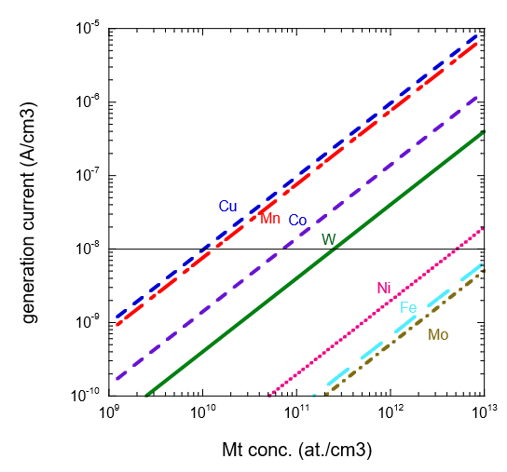

Figure 1. Mertens et al. 2016 - The calculated contribution of different metal impurities to the trap-assisted dark current generated per unit volume as a function of the volume concentration of metal-impurities in silicon.

UPW Metal Spec

There is general agreement that previously defined limits of metals in UPW used approach, which is inadequate to the currently used methodology of setting the roadmap targets. Current method implies the level of impurity at which the manufacturing yield will likely be affected. This limit is based solely on the effect to the device, as opposed to the previous approach taking into account metal occurrence and detectability…

As a result, the previously publish 2015 UPW ITRS table suggested the following limits:

|  |  |
| --- | --- |
| Metals (ppt each) (As, Ba, Cd, Mn, Pb, Sn, Sb, V), PPT | **<10** |
| Critical metals (ppt, each) (Al, Ca, Cr, Cu, Fe, K, Li, Mg, Na, Ni, Ti, Zn) (PPT) | **<1.0** |

As example of the controversy it can be seen that Al and Zn that are generally not considered to be critical per FEP, became critical in UPW table.

**The Issue**

Despite its criticality metal spec has not been updated. There is no clear and agreed process methodology to bring the spec to the condition that would adequately support future technology needs.

This document proposes the new methodology of setting metal spec and specific recommendation for metals in UPW for 2017/2018 roadmap update. The methodology is generally based on the experimental and modeling work by Paul Mertens and IMEC team as well as experience of UPW IRDS and SECC Critical Surface (CS) Team.

**The Methodology**

There are several following steps are considered in the process:

Step 0. Define list of the metals to be defined in the roadmap based on previous ITRS documents, both FEP and UPW ITRS tables (most of metals included independent of their criticality. Hf and Pt excluded due low probability of occurrence)

Step 1. Define metals limit on the wafer for non-image sensor applications (based on FEP/SECC CS input) – i.e., 5E+9 at/cm2

Step 2. Define metals limit on the wafer for image sensor applications (based on Mertens et al., 2016). Note: this reference was used due to relatively lower “impact” on the calculated sensitivity. Further increase of requirements to higher criticality will be considered in the future. - **1E+9 at/cm2** was listed for Cu and Mn. Other metals are expected to be at the level of general UPW or higher.

Steps 3. Define relative criticality of the metals – high, medium, and low-medium (based on FEP info and experience of Drew Sinha – UPW IRDS member). The level of relative criticality is considered to be used for the end user reference only, when specific parameter excursion management is needed.

Steps 4&5. Calculate UPW limits for the metals for general UPW and that of image sensors respectively.

* Single digit ppt for UPW and nearly an order of magnitude for Cu and Mn.

Note: it is important to clarify that the factor connecting wafer level contamination with that in the bulk liquid is based on the empirical data by Paul Mertens (personal communication) and the idea that during the wafer processing there is an accumulative deposition of the contamination present in the equivalent thickness of the water film on the wafer surface. In other words, if that films dries out all metals containing in it will deposit on the wafer.

The following conditions were captured when discussing the deposition conditions per above:

* no pH was controlled in the bath (pH 5.6 is expected due to ambient CO2) – high pH could drive different approach to deposition
  + Acid (CO2) is commonly used with UPW
* hydrophilic wafer
* 4-5 min HRT
* the experiment was based on naturally occurring metal levels (no spiking)
* spiking may affect pH
* Spin tool - in spin tool the diffusion is not a limiting factor

Two contribution mechanisms:

1. Immersion (normalized deposition is expected to be in the UPW layer equivalent of **5mm** for the spin - based on empirical data)

2. drying (2u can be assumed as the layer thickness that would deposit)

Time needs to be taken into account…

**The Outcome**



The data below developed by Japanese researchers generally supports the above outcome for critical Ca and Fe.

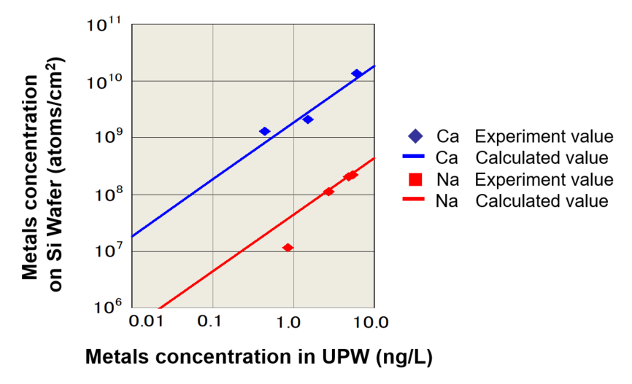

**Recommendation for the UPW IRDS Table**

1. Use the combined FEP/UPW tables list of 24 metals – this is slight increase compare to the previous one.
2. Round all metal targets for general UPW at 1 ppt level. This would align the list to existing 1ppt spec for “critical” metals
3. There is no criticality factor in defining limits. The severity of impacts are recommended for practical risk management purposes only.
4. List only Cu and Mn as critical metals for image sensors (at this point) with the target value of 0.2ppt.

**References**

Specification of trace metal contamination for image sensors Paul W. Mertens, Simone Lavizzari and Stefano Guerrieri 1 Imec, Remisebosweg 1, 3001 Leuven [paul.mertens@imec.be](mailto:paul.mertens@imec.be) (UCPSS 2016)

Metal Removal Efficiency in High Aspect Ratio Structures Philippe Garnier 1, a *, Herve Fontaine2 1 STMicroelectronics Crolles2, 850 rue Jean Monnet 38921 Crolles, France 2 Univ. Grenoble Alpes, F-38000 Grenoble, France - CEA, LETI, MINATEC Campus, F-38054 Grenoble cedex 9, France a [philippe-e.garnier@st.com](mailto:philippe-e.garnier@st.com). Solid State Phenomena Online:2016-09-05 ISSN: 1662-9779, Vol. 255, pp 313-318 doi:10.4028/www.scientific.net/SSP.255.313 © 2016 Trans Tech Publications, Switzerland

Takeo Fukui, Toshimasa Kato, Takaaki Chuuman, and Nobukazu Arai (2013) Drastic Reduction of Metallic Impurities in Water Using Ultrapure Ion-Exchange Resin. ULTRAPURE WATER Conference, Portland, OR, 2013

*Need to add reference to Paul Mertens presentation at ECS workshop describing the approach to metal deposition….*